Ministry of Science and Higher Education of the Russian Federation

ITMO University

Institute of Design & Urban Studies

Digital Urban Studies

07.04.04 Urban Planning

THESIS

Final Thesis

Subject of the assignment:

Assessing Sustainable Land Use Scenarios in Xixian New Area: Multi-Scenario Simulation, Entropy Weight Method and Coupling Model

Student:

Liu Ming

17.04.2025

Supervisor

Prof. Irina A. Shmeleva, PhD, Docent, Ordinary Associate Profesoor

17.04.2025

St. Petersburg

2025

Table of Contents

[1 Introduction 6](#_Toc16088)

[1.1 Background of the study and formulation of the problem 6](#_Toc2776)

[1.2 Research Problem 6](#_Toc20957)

[1.3 Research Objectives And Tasks 7](#_Toc16372)

[1.4 Theoretical Foundations And Key Literature 8](#_Toc8108)

[1.5 Thesis Structure Arrangement 9](#_Toc26683)

[2 Literature Review 10](#_Toc26202)

[2.1 Background and theoretical basis for the concept of sustainable development 10](#_Toc30666)

[2.1.1 Theoretical evolution and international origin 10](#_Toc9853)

[2.1.2 Theoretical basis: from general development to sustainable development 11](#_Toc7690)

[2.2 Research on sustainable urban development: multidimensional framework and evaluation modeling 12](#_Toc26210)

[2.3 Theory of sustainable land use: intensive, equitable and coordinated development 13](#_Toc4752)

[2.4 Theoretical integration and research gaps in this study 14](#_Toc2010)

[3 Analysis of Current Land Use Situation and Problems in Xixian New Area 16](#_Toc24107)

[3.1 Overview of Xixian New Area and Urban Spatial Characteristics 16](#_Toc3479)

[3.2 Mapping Sustainable Development Issues in Xi'an 17](#_Toc10601)

[3.2.1 Ecology, the most visual manifestation of sustainable development 17](#_Toc21541)

[3.2.2 Comprehensive Analysis of Urban Problems 23](#_Toc9224)

[3.3 Problems and Challenges of Land Use in Xixian New Area 25](#_Toc9227)

[3.3.1 Outstanding contradiction between supply and demand of land resources 25](#_Toc30003)

[3.3.2 Contradiction between ecological protection and land development 25](#_Toc28055)

[3.3.3 Insufficient match between public facilities and residents' needs 26](#_Toc25220)

[3.4 Summary of this chapter 26](#_Toc17504)

[4 Construction of Sustainable Development Evaluation System and Weight Calculation 27](#_Toc3094)

[4.1Construction of evaluation index system 27](#_Toc20019)

[4.1.1 Theoretical framework of the indicator system based on SDGs 27](#_Toc19757)

[4.1.2 Principles and Methods of Indicator System Construction 27](#_Toc7517)

[4.1.3 Specific indicator system setting 28](#_Toc15073)

[4.2 Entropy weighting method to calculate planning weights 33](#_Toc6090)

[4.2.1 Data standardization and pre-processing 34](#_Toc420)

[4.2.2 Entropy weight method calculation steps and results 34](#_Toc8069)

[4.3 Questionnaire survey and calculation of regional weights and scenario demand weights 36](#_Toc23555)

[4.3.1 Questionnaire Design and Data Collection Methods 36](#_Toc10964)

[4.3.2 Statistics and analysis of questionnaire data 37](#_Toc7538)

[4.3.3 Calculation of regional weights and scenario demand weights 38](#_Toc9364)

[4.4 Summary of this chapter 38](#_Toc15785)

[5 Coupled Coordination Degree Model and Optimization of Multi-Scenario Land Use Simulation 40](#_Toc17575)

[5.1 Description of Models and Indicators 40](#_Toc24551)

[5.2 Scenario Setting and Modeling Objectives 41](#_Toc18605)

[5.3 Optimization model parameters and constraints setting 42](#_Toc15677)

[5.3.1 Parameter setting 42](#_Toc30615)

[5.3.2 Constraint setting 43](#_Toc21079)

[5.4 Optimization objective function setting 43](#_Toc28384)

[5.5 Summary of this chapter 44](#_Toc29783)

[6 Analysis of results of multi-scenario simulation optimization 45](#_Toc28265)

[6.1 Six sets of optimization models with initial planning scenarios 45](#_Toc19904)

[6.2 Visualization of results 46](#_Toc16454)

[6.3 Trend Analysis and Comparison of Perspectives 47](#_Toc2947)

[6.4 Identification of optimal scenarios and analysis of specific results 48](#_Toc1035)

[7 Optimal scenario analysis and its policy recommendations 52](#_Toc940)

[7.1 Optimal Scenario Identification and Result Analysis 52](#_Toc8526)

[7.2 Recommendations for regional development under the optimal scenario 56](#_Toc10820)

[7.3 Policy Recommendations under Ecological Orientation 57](#_Toc898)

[7.4 Summary 58](#_Toc3673)

[8 Construction of Green Development Supervision System 59](#_Toc4434)

[8.1 Background and Research Logic 59](#_Toc10329)

[8.2 Indicator System Construction and Reference 59](#_Toc9251)

[8.3 Calculation and working principle of green development indicator system 67](#_Toc19480)

[8.4 Summary of this chapter 67](#_Toc10350)

[9 Conclusion and Outlook 69](#_Toc25662)

[9.1 Main Research Findings 69](#_Toc5638)

[9.2 Contributions of the Study 70](#_Toc2547)

[9.3 Limitations and Future Research 70](#_Toc10129)

[Reference 72](#_Toc25334)

**1 Introduction**

**1.1 Background of the study and formulation of the problem**

As the global urbanization process continues, the demand for land resources continues to grow, and the ecological and environmental pressures brought about by the expansion of urban space are becoming increasingly significant. According to the 2030 Agenda for Sustainable Development issued by the United Nations, cities should realize systematic protection of the ecological environment while pursuing economic growth and social equity, and explicitly put forward 17 Sustainable Development Goals (SDGs), including “sustainable cities and communities” [[[1]](#endnote-0)]. In this context, the efficient utilization and scientific management of land have gradually become the core issues in realizing sustainable urban development.

In recent years, China's urbanization rate has been increasing, reaching 65.2% by 2023. In the process of rapid development, some areas have been subject to sloppy land development, ecological degradation and uneven public services. Therefore, the state has put forward the national strategies of “green development” and “ecological civilization construction”, encouraging the green transformation of urban systems through scientific planning and land structure optimization [[[2]](#endnote-1)][[[3]](#endnote-2)]. As the first national new area in the northwest of China, Xixian New Area, while assuming the important task of Xi'an-Xiamen-Yang integrated development experiment, is also in urgent need of exploring the green land use path that can be popularized, evaluated, and monitored.

**1.2 Research Problem**

Based on the above background, this study focuses on the following three core questions:

(1) How to realize the synergistic optimization of land use structure among the three objectives of ecological protection, social equity and economic efficiency?

(2) How to establish a coordinated and adjustable weighting system between the government's planning orientation and the public's diversified needs?

(3) How to build a green development monitoring system with quantitative scoring and feedback capabilities?

**1.3 Research Objectives And Tasks**

This study aims to construct a set of land sustainable use evaluation, optimization and supervision methods applicable to the green development objectives of new national-level zones, and conduct systematic modeling and validation with Xixian New Area as the empirical area.

Specific research objectives include:

1. Constructing a land-use sustainability evaluation system covering ecological, social and economic three-dimensional objectives;

2. determine the weights of land use planning under the perspective of government planning by using the entropy weight method;

3. based on the results of the public questionnaire survey, obtain the regional weights according to the functionality of the cluster area, and obtain the scenario demand weights under different simulation scenarios according to the public demand;

4. using genetic algorithm to simulate the land structure optimization scheme under three types of simulation scenarios: ecological, social and economic;

5. based on the coupling coordination model, evaluate the synergistic performance of different scenarios from the public perspective and the government perspective;

6. obtain the optimal scenario optimization plan and the best simulation scenario based on the overall score. At the same time, provide suggestions for the spatial layout with the best scenario as the development goal;

7. Construct a monitoring and evaluation system for green development and realize the closed-loop operation of the indicator-based monitoring and feedback mechanism.

**1.4 Theoretical Foundations And Key Literature**

The theoretical support system of this study consists of the following six main areas:

1. urban sustainable development theory: UN-Habitat (2015); United Nations (2015), Transforming Our World: The 2030 Agenda for Sustainable Development[1]; S. Shmelev & I. Shmeleva (2019, 2025)[[[4]](#endnote-3)][[[5]](#endnote-4)] and other proposed multidimensional sustainable city measurement frameworks;

2. Multi-indicator comprehensive evaluation method: Hair et al. (2010), Multivariate Data Analysis [[[6]](#endnote-5)] provides theoretical support for indicator normalization processing and weight assignment;

3. Entropy Weight Method (Entropy Weight Method): quantifies the effectiveness of each indicator through information entropy and forms an objective assignment mechanism [6];

4. Coupling Coordination Degree Model: Fang et al. (2017), Coupling coordinated development between urbanization and the eco-environment in China [[[7]](#endnote-6)], used for the analysis of the coordination of the three objectives of the urban system;

5. National Green Development Indicator System: a pilot indicator system document developed by the National Development and Reform Commission to provide a grading and indexing basis for this research and monitoring system [3];

6. Sustainable urban spatial strategies: Shmelev (2019), Sustainable Cities Reimagined [4], and X. Li (2019), Experience of Urban Functional Construction in Tokyo Metropolitan Area and Its Enlightenment to China [[[8]](#endnote-7)].

**1.5 Thesis Structure Arrangement**

This paper is divided into eight chapters, and the contents of each chapter are as follows:

Chapter 1: Introduction

Chapter 2: Literature Review

Chapter 3: Current Situation and Problem Analysis of Land Use in Xixian New Area

Chapter 4: Evaluation System Construction and Weight Determination

Chapter 5: Multi-Scenario Simulation and Land Use Optimization

Chapter 6: Coupling Coordination Analysis and Scenario Comparison

Chapter 7: Optimal Scenario Analysis and Regional Policy Recommendations

Chapter 8: Green Development Supervision System Construction

Chapter 9: Conclusion and Outlook

**2 Literature Review**

**2.1 Background and theoretical basis for the concept of sustainable development**

**2.1.1 Theoretical evolution and international origin**

The origin of sustainable development as a concept can be traced back to Howard's idea of “idyllic city” in the early 20th century, which advocated the integration of cities with nature [[[9]](#endnote-8)]. Subsequently, urban ecology, environmental protection movement and the concept of “sustainable development” have gradually deepened its theory, and in 1972, the Club of Rome released the report “The Limits to Growth”, which for the first time proposed that there are resource limits to human development, further promoting the idea of sustainable development into the global perspective [9]. In 1972, the “Club of Rome” released the report “Limits to Growth”, proposing for the first time that there are resource limits to human development, further promoting the idea of sustainable development into the global perspective [[[10]](#endnote-9)].

In 1987, the United Nations “Our Common Future” report for the first time systematically defined the concept of “sustainable development”, put forward to meet the needs of the current generation without compromising the ability of future generations to develop the basic principles [1]. the end of the twentieth century, Europe and the United States to deal with the process of industrial pollution and urban congestion, the gradual development of green economy, green energy and eco-city concepts, and later on, to provide the basis for the concepts of green economy, green energy and eco-city. In the late 20th century, Europe and the United States, in the process of dealing with industrial pollution and urban congestion, gradually developed the concept of green economy, green energy and eco-city, laying the foundation for the construction of the sustainable development system.

Since the 21st century, the concept of sustainable development has been increasingly institutionalized globally. The United Kingdom first proposed low-carbon cities in “Our Energy Future” (2003) [[[11]](#endnote-10)]. China has systematically deployed green development paths in its 13th Five-Year Plan, while the United States, Germany, Sweden, Japan and other countries have practiced energy efficiency, circular economy and sustainable urban governance, forming a set of policies, technologies and spatial support systems [2].

**2.1.2 Theoretical basis: from general development to sustainable development**

The concept of sustainable development is a reflection and transformation of the traditional economic growth-oriented development logic. The concept emphasizes the synergistic development of the three systems of society, economy and ecology, and is a systematic correction of the ills of industrial civilization in the 20th century. Compared with traditional development thinking, sustainable development emphasizes the renewability of natural resources, intergenerational equity, and the holistic value of ecosystem services.

The concept of sustainable urban development can be roughly divided into three levels:

(1) The theory of sustainable development: originating from the United Nations “Brundtland Report” [1], it emphasizes intergenerational equity and systemic balance, and has become the value basis for global environmental governance;

(2) Urban Complex Ecosystem Theory: the city is regarded as a complex adaptive system consisting of the interaction of three major systems: ecology, economy, and society, emphasizing the coordination and feedback mechanism between the subsystems, which is the structural framework of the current research on sustainable urban planning and spatial governance [3];

(3) Green technology application: covering new energy utilization, green infrastructure, carbon neutral assessment, etc., providing means of implementation and engineering carriers for sustainable development [4];

**2.2 Research on sustainable urban development: multidimensional framework and evaluation modeling**

In the book Sustainable Cities Reimagined: Multidimensional Assessment and Smart Solutions, published in 2019, Shmelev emphasizes that urban sustainability should not be reduced to a single-indicator growth target, but should be achieved through ecological, economic, social, system of indicators constructed through multiple dimensions such as ecological, economic, social, institutional, and technological, emphasizing the importance of systemic thinking in the management of urban complexity [4].

In the same work, Tonks and Shmelev made a systematic comparison of more than 10 international mainstream urban sustainability frameworks, and pointed out that: fragmentation should be avoided when constructing a sustainability indicator system, and a collection of indicators with structural consistency and comparative adaptability should be constructed based on the coupling mechanism of urban systems [[[12]](#endnote-11)].

In their article “Smart and sustainable benchmarking of cities and regions in Europe”, published in the journal Cities in 2025, Shmelev and Shmeleva proposed a “Smart benchmarking framework for urban and regional sustainability”, which uses a multi-criteria decision-making framework to assess the sustainability of cities and regions. ”, which employs a multi-criteria decision analysis (MCDA) approach to rank European regions and cities comparably and introduces visual visualization and spatial multidimensional mapping methods to present the comprehensive performance of cities [5].

In the study “Multidimensional Ecosystem Mapping” published in the journal Sustainability in 2023, Shmelev and other scholars proposed to embed natural ecosystem services into the urban planning assessment framework, advocating “ecosystems' contribution to humanity” as the starting point for spatial assessment. “ as the starting point of the spatial assessment approach to empower the value of urban natural elements [[[13]](#endnote-12)].

**2.3 Theory of sustainable land use: intensive, equitable and coordinated development**

The land system is an important supporting subsystem for urban sustainability research.Fang et al. (2017) proposed a “coupled coordination model” in the Journal of Geographical Sciences for assessing the synergistic relationship between the urbanization process and the ecological environment. Their study concluded that urban land use sustainability is not only reflected in the development efficiency, but also in the ability to balance between ecological and social functions [7].

In Sustainable Cities Reimagined, Shmelev and Zhang (2019) focus on the evaluation of land systems in “cities of the global South” and propose that the sustainability of urban land use structures should be centered around ” The sustainability of urban land use structure should be assessed in terms of green infrastructure accessibility, functional mixing ratio, land density and social service equity”, and a multi-layer nested indicator structure should be constructed [[[14]](#endnote-13)].

In another article led by Shmelev, “Global urban sustainability assessment: A multidimensional approach”, the authors pointed out that at the land use level, we should pay attention to the indicators of ecological service carrying capacity, transportation circulation, housing density, industrial space utilization, and emphasize the system resilience and public satisfaction oriented. system resilience and public satisfaction-oriented urban spatial structure adjustment [[[15]](#endnote-14)].

At the level of China's green development policy, the China Green Development Indicator System (Trial) issued by the National Development and Reform Commission explicitly lists more than 20 monitoring indicators closely related to land use, including the area of construction land per unit of GDP, the growth rate of construction land, the intensity of the ecological red line control, and the rate of urban green space, which provides a systematic basis for the construction of a local land sustainability indicator system in this study [3].

**2.4 Theoretical integration and research gaps in this study**

Although the current literature has formed a systematic framework for urban sustainability assessment and land use optimization, there are still deficiencies in practical application:

1. For China's national new areas, which are a spatial type of “planning first, construction later”, the research system still focuses on mature cities, and lacks a systematic simulation of the situational and stage-by-stage sustainability of new areas;

2. Most of the studies adopt the expert judgment method for weight allocation, and the systematic introduction and quantification of the public participation perspective is still weak;

3. most of them are disconnected between the indicator system and land optimization, and the closed-loop monitoring system for policy feedback is not well designed.

In order to compensate for the above shortcomings, this study will carry out the following theoretical innovations:

1. Combine the multidimensional sustainability evaluation framework constructed by Shmelev et al. with the system coupling model proposed by Fang et al. to construct a three-category weighting mechanism (planning, region, and demand), and fully incorporate the public perspective;

2. Use genetic algorithms to simulate three types of land optimization scenarios: ecological, social and economic, and conduct systematic evaluation and screening of optimal scenarios based on the coupling model;

3. Referring to the national green development index system, build an integrated mechanism of “simulation-assessment-feedback-supervision” to form a practicable sustainable development management system.

The above research will provide theoretical support for the construction of a systematic, dynamic and operable land sustainability evaluation and spatial governance mechanism in Xixian New Area, a national new area.

**3 Analysis of Current Land Use Situation and Problems in Xixian New Area**

**3.1 Overview of Xixian New Area and Urban Spatial Characteristics**

As the first state-level new area in Northwest China, Xixian New Area is located between Xi'an and Xianyang, with a total planning area of 882.20 square kilometers, and the jurisdiction is divided into five functional clusters, namely, Airport New City, Fengyong New City, Qinhan New City, Fenghi New City and Jinghe New City [[[16]](#endnote-15)]. The region concentrates rich natural resources, historical and cultural heritage and rapidly developing industrial clusters, and is an important support platform for the spatial expansion and functional enhancement of Xi'an Metropolitan Area.

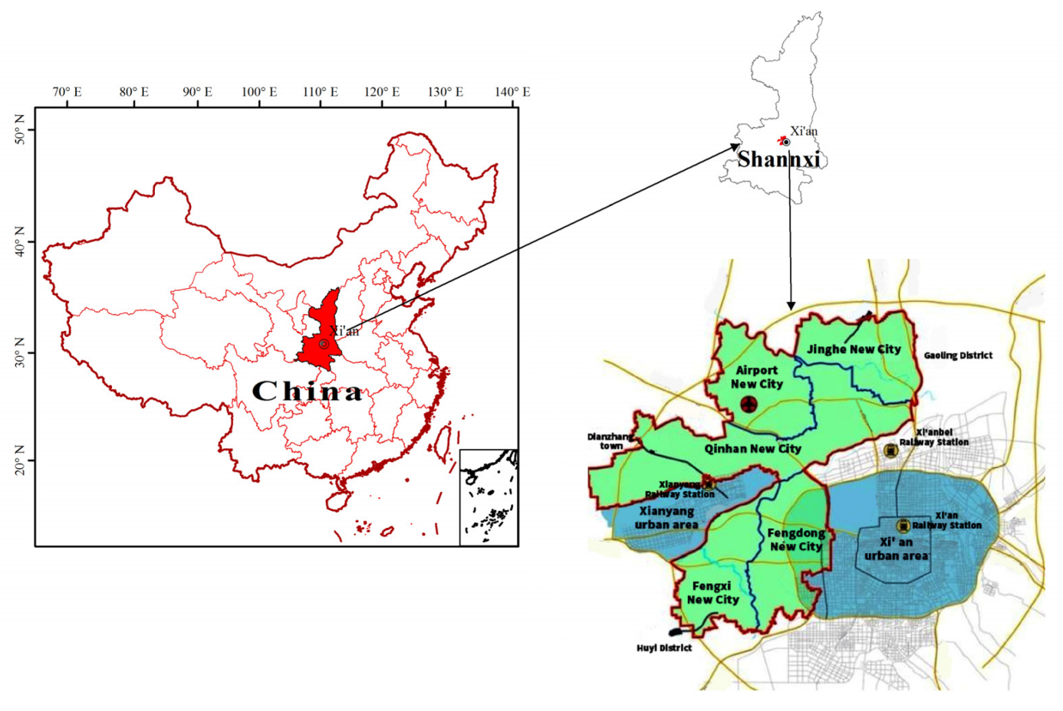

Figure 1 — The location of Xixian New Area and its five groups[[[17]](#endnote-16)]

In terms of spatial structure, Xixian New Area has formed a spatial pattern of “one river, two belts, four axes and five clusters”, with green eco-corridors along both sides of the Weihe River, and relying on the existing transportation arteries and historical relics, showing the idyllic urban characteristics of “wide-open, wide-open, sparse and dense”. The city is characterized by an idyllic urban landscape. Currently, the total amount of construction land is 237.63 km², of which urban construction land accounts for about 47%, with residential, industrial and transportation as the dominant areas, while the land for public services, green space and cultural functions is still insufficient.

Compared with the central city of Xi'an, the population density of Xixian New Area is low (about 1,124 people/km²), and the population growth rate is slow, presenting the typical characteristics of “new area” with long distance between clusters and scattered spatial layout [[[18]](#endnote-17)].

**3.2 Mapping Sustainable Development Issues in Xi'an**

As the home city of the Xixian New Area, Xi'an is currently facing challenges in many dimensions, including ecological restoration, social development and economic transformation, and its experiences and problems directly affect the spatial layout and land policy of the Xixian New Area.

As the ancient capital of China during the 13th Dynasty, Xi'an has a long history. However, this also means that the ecological environment around Xi'an will be affected by human activities for a long time. From logging to build cities and reclaiming wasteland in the feudal era to pollution emissions in the industrial era, these activities have made Xi'an's ecological environment very fragile. Its ecological regulatory capacity is also weak and highly susceptible to collapse under external forces.

**3.2.1 Ecology, the most visual manifestation of sustainable development**

(1) Qinling Mountains

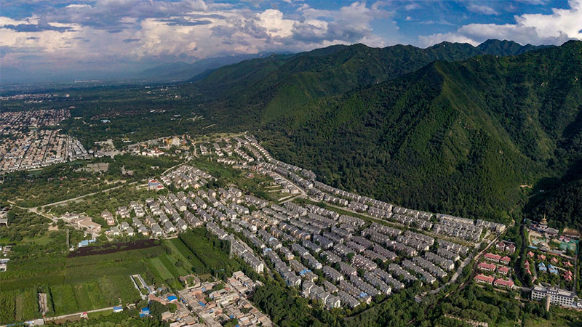

Figure 2 — Overhead view of unauthorised villas in Qinling[[[19]](#endnote-18)]

In July 2018, the «demolition of illegally built villas in Qinling Mountains» attracted the attention of the Chinese government and people: Due to the corruption and bribery of officials from the Shaanxi Provincial Government and the Xi'an Municipal Government, criminals built 1,194 illegal villas in the Qinling Mountains. This not only seriously affects the ecological environment of Qinling Mountains, but also is a money transaction within the government. In 2014, after the incident of the villa was exposed, the then Chinese President Xi Jinping issued an order requiring the Xi'an municipal government to immediately demolish the illegal buildings. However, due to the formalism and bureaucracy of local government officials, the local government only reported the number of 200 buildings. From then until 2018, President Xi Jinping issued six instructions on this matter, but all of them were ignored by the local government. Finally, in July 2018, the illegal building was demolished after being dealt with by the special investigation team of the central government. Then, in January 2019, China Central Television made the matter into a documentary – “Catching the Righteous Discipline to the End – The Beginning and End of the Rectification of Illegal Construction in Qinling Mountains“[[[20]](#endnote-19)], which told the whole incident.

In addition to the government's illegal construction, the problem of mining areas in the Qinling Mountains has also been serious in the past few decades. Mining enterprises willfully destroy the ecological environment of the Qinling Mountains and expand mining areas on a large scale. According to Xinhua News Agency[[[21]](#endnote-20)], in the Qinling Mountains Environmental Protection Zone, there were at most nearly 170 mining areas of different sizes and nearly 300 illegal hydropower stations at the same time. This is undoubtedly a heavy burden on the ecosystem of the Qinling Mountains. Fortunately, in recent years, with the Xi'an Municipal Government actively promoting the issue of mining areas in the Qinling Mountains. As of now, there are no mining areas in the key areas of the Qinling Mountains, and the ecological area of the restored mining areas in the entire Qinling Mountains has reached more than 10,000 mu.

(2) Water Pollution

Xi'an is a resource – intensive water-scarce area. According to statistics in 2020[[[22]](#endnote-21)], the total water resources of Xi'an City are 2.68 billion cubic meters, and the per capita surface water resources are about 260 cubic meters, which is one–seventh of China's per capita water resources. One thirty–fourth of the world's per capita water resources (8800 cubic meters). However, in the face of such a shortage of water resources, the water pollution in Xi'an City was very serious:

1.Groundwater

Xi'an used to use groundwater as a source of drinking water. However, after thousands of years of people's use and discharge of domestic sewage, Xi'an's groundwater has long since become undrinkable. According to historical records, when the Sui Dynasty (ancient Chinese dynasty) was established 1,400 years ago, Emperor Sui Yang was forced to build a new capital in Longshouyuan (place name) because the groundwater in Xi'an was undrinkable.

In modern times, coupled with the discharge of industrial waste water in the industrial era, the groundwater quality in Xi'an has become even worse. At one time, areas with poor and extremely poor groundwater quality accounted for 54.1% of the total area[[[23]](#endnote-22)].

Faced with such a serious situation, the Xi'an Municipal Government has taken the following measures to prevent:

1. Restrict groundwater exploitation
2. Addition of sewage treatment plant
3. Improve sewage treatment technology

Today, with nearly 10 years of treatment, the problem of groundwater pollution in Xi'an has been effectively alleviated. According to the statistics of 8 waterworks in Xi'an, the qualified rate of water quality in Xi'an's water sources has reached over 95%.

2.Surface water

Since ancient times, Xi'an has been known as “八水绕长安“ (eight rivers surround the city). But 20 years ago, the surface rivers in Xi'an, including the moat, were polluted by industry, and the river water was dirty and smelly. It was once a serious ecological pollution problem in Xi'an.

In 2003, after the Xi'an Municipal Government established the moat comprehensive reconstruction project, the Xi'an Municipal Government carried out three large-scale governance actions on the moat. By 2020, the water quality of the moat in Xi'an will be upgraded to Class III standard for surface water.

In addition to renovating the moat, in 2019, the Xi'an Municipal Government issued the “Three-Year Action Plan for Water Control in the Whole Region, Prosperity with Clear Water, and Protection and Management of Rivers and Lakes in Xi'an“[[[24]](#endnote-23)]. After three years of action, the water quality of the surface rivers in Xi'an has been significantly improved: the Weihe River, Bahe River, and Chan River have been reborn, and the water quality of the rivers has all reached China's national standard of Class IV or above (based on agricultural and industrial water requirements) In addition to being suitable for agriculture and some industrial water, it can be used as drinking water after proper treatment) Good water environment has returned to the daily life of Xi'an citizens.

(3)Air pollution

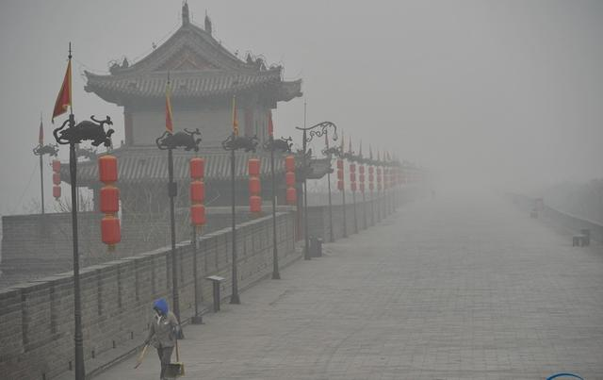

Figure 3 — Xi'an winter haze[[[25]](#endnote-24)]

Ten years ago, when winter came, the sky in Xi'an would be shrouded in gray. Among them, from December 18 to December 25, 2013, a smog that lasted for 8 days left a deep impression on many Xi'an people.

In 1995, the United Nations conducted a network monitoring of global ambient air pollution. In the ranking of particle pollution in 40 cities around the world, Xi'an, as a city selected for the monitoring network, has very serious pollution and is one of the most serious cities.

Faced with such severe air pollution, the Xi'an Municipal Government is actively implementing pollution control and smog reduction. Not only that, the Xi'an municipal government has listed the air pollution control project as the number one livelihood project, and has adopted a series of measures[[[26]](#endnote-25)]:

1. In 2017 alone, Xi’an dismantled 636 coal-fired boilers outside the urban area and 40 coal–fired boilers in garrison units, totaling 676 coal-fired boilers with a capacity of 1385.19 steam tons. According to estimates, such demolition actions can reduce annual coal consumption by about 483,000 tons, reduce sulfur dioxide emissions by about 6,568.8 tons, reduce nitrogen oxide emissions by about 1,420 tons, and reduce smoke and dust emissions by about 11,012.3 tons.
2. By 2022, Xi'an's smart environmental protection project will establish an all-round environmental monitoring network; use intelligent technology to form an environmental management model with big data as the core, and improve the environmental supervision level of Xi'an. In addition, 241 sets of gridded air monitoring stations have been built in Xi'an, and 8 sets of online monitoring systems for corporate pollution sources (organic waste gas) have been added.

Today, according to statistics[[[27]](#endnote-26)], in 2021, the number of days of good weather in Xi'an will reach 265 days, with an excellent rate of 72.6%; the number of days with severe and above pollution will be 8 days, a year–on–year decrease of 6 days. The three indicators of good days, PM2.5 concentration and heavy pollution days in Xi'an have all improved.

(4)Green area



Figure 4 — Xi'an Green Zone[[[28]](#endnote-27)]

After vigorously building ecological parks, the green area of Xi'an has been greatly improved. From 109.59 million square meters in 2010, by 2020, the total urban green area will reach 358.5 million square meters. Among them, in 2020 alone, the newly added urban green area in Xi'an will reach 9.05 million square meters[[[29]](#endnote-28)].

According to statistics in 2021, there are 146 urban parks in Xi'an, which are divided into ecological parks, heritage parks, wetland parks, sports parks, forest parks and other types.

**3.2.2 Comprehensive Analysis of Urban Problems**

As shown in the ecological environment above, there are still many problems and chall2enges to be solved in the three aspects of sustainable development in Xi'an.

(1) Status and challenges of ecological and environmental governance Xi'an, as one of the core cities in Northwest China, has promoted water restoration and air quality improvement through a series of policies in recent years. For example, the number of good air quality days in the city will reach 265 days in 2021, an increase of 15 days from 2020, and the annual average concentration of PM2.5 will be reduced to 41 μg/m³ [25]. In terms of water pollution management, through the establishment of a special action for water body restoration, the complete remediation of 21 black-smelling water bodies has been realized, and the standard rate of centralized drinking water sources in the main urban area has reached 100% [[[30]](#endnote-29)]. However, ecosystem restoration still requires long-term investment, especially in the case of water scarcity (260m³/year per capita) and high pollution load pressure coexist, the ecological carrying capacity still exists limit.

(2) Problems of Social Structure and Unequal Public Services Xi'an has strong higher education resources, with 63 colleges and universities and 784,000 college students, ranking among the top six cities in the country in terms of college density [[[31]](#endnote-30)]. However, at the basic education stage, the uneven regional development within the city and the lack of educational fairness are still prominent. in 2018, the Ministry of Education named Xi'an's private education problem, and there is still a structural tilt in the flow of teachers and resources to the private sector by 2020 [[[32]](#endnote-31)].

In terms of medical resource allocation, the old city hospitals are concentrated, while new areas such as Xixian part of the regional medical facilities have not been improved. Insufficient support leads to “new city is not new”, exacerbating the burden of services in the old city.

(3) Economic Structure and Energy Issues Xi'an is a major manufacturing center in the central and western regions, but it has long relied on coal energy, which has resulted in high carbon emissions. The government encourages low-carbon transportation and shared mobility, such as promoting shared bicycles to reduce carbon emissions by 13,000 tons by 2022 [[[33]](#endnote-32)]. At the same time, “Qinchuangyuan” as a platform to create a high technology plateau, promoting high-tech enterprises exceeded 12,000 [[[34]](#endnote-33)].

(4) Land Use and Urban Expansion Issues From the perspective of urban planning evolution, Xi'an has experienced the expansion path of “single-center old city + multi-cluster new city”, but there are problems such as poor traffic penetration and construction land exceeding ecological capacity. Xixian New Area is facing the risk of replicating these typical urban sprawl problems, such as insufficient rail transit connections between Xi'an and the city, and the inter-district commuting load is as high as 1.04 million trips per day, accounting for 42% of the city's total urban trips [[[35]](#endnote-34)].

**3.3 Problems and Challenges of Land Use in Xixian New Area**

**3.3.1 Outstanding contradiction between supply and demand of land resources**

With the rapid economic development and population increase in the new area, the intensity of land development is increasing, and the demand for construction land is growing rapidly, which has obviously exceeded the sustainable supply capacity of land resources, and the contradiction between the supply and demand of land resources is becoming more and more prominent.

**3.3.2 Contradiction between ecological protection and land development**

The rich ecological resources and historical and cultural resources of the new area have put forward higher requirements for regional ecological protection, but the ecological damage brought about by the rapid development of land in the new area is becoming increasingly obvious, and the coordinated development of land development and ecological protection is facing a serious challenge.

**3.3.3 Insufficient match between public facilities and residents' needs**

The proportion of land for public facilities in the new district is low, and the supporting facilities for urban public services are insufficient, especially the construction of public facilities such as medical care, education and culture is lagging behind, which is unable to meet the demand for public services due to population growth.

**3.4 Summary of this chapter**

This chapter analyzes the current situation of land use in Xixian New Area and the main problems, reveals the contradiction between the development of land resources and ecological protection in the new area, and puts forward the key issues that need to be focused on and solved in the future land use planning of the new area, which provides a realistic basis for the next step of carrying out the optimization of multi-scenario simulation.

**4 Construction of Sustainable Development Evaluation System and Weight Calculation**

**4.1Construction of evaluation index system**

**4.1.1 Theoretical framework of the indicator system based on SDGs**

In order to comprehensively evaluate the sustainability of land use in Xixian New Area, this study takes the 17 Sustainable Development Goals (SDGs) proposed by the United Nations as the theoretical guiding framework, combines with the actual situation of land use planning in Xixian New Area, divides the land use types in the new area into 18 specific land use types, and categorises them based on the three target levels of ecological, social and economic goals to make them an indicator layer, in order to more clearly reflect the the specific allocation of land resources under different sustainable development objectives.

**4.1.2 Principles and Methods of Indicator System Construction**

The construction of the indicator system follows the principles of scientificity, comprehensiveness, operability, representativeness and goal orientation. Through literature review, actual planning needs of Xixian New Area, it is ensured that the indicator system can effectively reflect the land use structure and planning orientation of the new area. Based on the actual planning land use data of the new area, the specific land use types corresponding to each of the three target layers of ecology, society and economy are clarified through data collation and analysis[3][6].

The indicator system of this study is informed by the theoretical framework of international urban sustainability assessment. In a study published in 2002, Spangenberg noted that the institutional dimension is an integral part of measuring urban sustainability, particularly in the context of land governance [[[36]](#endnote-35)]. Building on this foundation, Shmelev further proposes a multidimensional indicator structure that emphasizes ecological, economic, institutional, social, and technological dimensions in Sustainable Cities Reimagined [4].

Here, considering the design of land planning for the new urban area of ​​Xixian New District, this study adopts the target layer-indicator layer system. And take the ecology, economy and society as the three pillars of sustainable development as the three target layers.

**4.1.3 Specific indicator system setting**

The ecological target layer includes land use types such as basic green space and park green space; the social target layer includes land use types such as residential land and educational land; and the economic target layer includes land use types such as commercial land and industrial land.

Table 1 — Land use evaluation system

| Target Level | Indicator Level |
| --- | --- |
| Economic | Commercial Land |
| Industrial Land |

Continuation table 1

|  |  |
| --- | --- |
| Social | Educational Land |
| Government Land |
| Medical Land |
| Cultural Land |
| Public Facilities Land |
| Social Welfare Land |
| Residential Land |
| Sports Land |
| Transport Station Land |
| Historical Site Protection Zone |
| Ecology | Agricultural Land |
| Agricultural and Forestry Land |
| Basic Green Space |
| Park Green Space |
| Water Area |
|  | Basic Land |

The rationale for the classification of the indicators is set out below:

Table 2 — Rationale for the classification of indicators

|  |  |
| --- | --- |
| Indicator Level | Rationale |
| Commercial Land | Supports urban economy and retail activities |
| Industrial Land | Promotes production and employment opportunities |
| Educational Land | Provides basic education services to population |
| Government Land | Enables administrative functioning and civic services |
| Medical Land | Ensures healthcare provision and public health infrastructure |
| Cultural Land | Preserves cultural identity and supports tourism |
| Public Facilities Land | Supports community infrastructure and daily functioning |
| Social Welfare Land | Addresses welfare for vulnerable groups |

Continuation table 2

|  |  |
| --- | --- |
| Residential Land | Core element of urban housing and living space |
| Sports Land | Encourages physical health and recreational equity |
| Transport Station Land | Supports urban mobility and public transport system |
| Historical Site Protection Zone | Preserves cultural heritage and identity |
| Agricultural Land | Maintains ecological buffer zones and biodiversity |
| Agricultural and Forestry Land | Maintains ecological buffer zones and biodiversity |
| Basic Green Space | Provides environmental functions and urban ventilation |
| Park Green Space | Supports urban aesthetics and psychological well-being |
| Water Area | Maintains natural hydrological cycles and biodiversity |

Calculation Formula for the Indicator Layer Score

Indicator stratum score is calculated based on the area ratio and corresponding weights for each land use type.

Score formula under planning weights:

 (1)

Score formula under demand scenario weights:

 (2)

:Score for the jth land use type in the i-th region according to the planning weights.

:The ratio of the area of the jth land-use type in the i-th region to the area in the i-th region.

:Planning weights, entropy weights for the jth land use type calculated using the entropy weight method (EWM).

:Regional weights, based on the questionnaire, for the jth land use type in the i-th region.

:Scaling factor to avoid calculation errors due to too small values.

5:Scaling factor to avoid calculation errors due to too small values.

: Scenario demand weights, weights for the jth land use type under the ath scenario demand according to the questionnaire.

:After optimisation, a score for the jth land use type in the i-th region is calculated based on the scenario demand weights.

Calculation Formula for the Target Layer Score

The target layer score is calculated as the average score of all indicator layers within the same sustainability category (economic, social, ecological). The formula is:

 (3)

:Score for the kth target stratum (economic, social or ecological sustainability) in region j.

m: Number of land use types in the indicator layer under the target layer.

: Score for the jth land use type in the ith region.

**4.2 Entropy weighting method to calculate planning weights**

Among various objective and subjective weighting methods such as AHP, Delphi and CRITIC, entropy weighting method was chosen in this study because of its data-driven and highly objective nature.

Table 3 — Methodological statistics

|  |  |
| --- | --- |
| Method | Type |
| Entropy Weight Method (EWM) | Objective |
| Analytic Hierarchy Process (AHP) | Subjective |
| CRITIC Method | Objective |
| Delphi Method | Subjective |

①Entropy Weight Method (EWM):

Data Dependency: Relies on variation in raw data;

Advantages: High objectivity, simple calculation, suitable for large-scale quantitative indicators;

Disadvantages: Does not consider logical structure among indicators.

②Analytic Hierarchy Process (AHP):

Data Dependency: Does not rely on data, based on expert judgment;

Advantages: Reflects human cognitive structure, suitable for small-scale evaluation;

Disadvantages: Easily influenced by subjective bias.

③CRITIC Method:

Data Dependency: Relies on standard deviation and correlation among indicators;

Advantages: Considers both variability and conflict among indicators;

Disadvantages: Complex computation, requires strong mathematical foundation.

④Delphi Method:

Data Dependency: Relies on expert consensus;

Advantages: Captures group consensus, suitable for policy-oriented issues

Disadvantages: High consultation cost, not suitable for large samples

The target of this study is as many as 3000 pieces of land use information with different attributes, and with such a large amount of data, the entropy weighting method can best reflect the information of the data itself. At the same time, land planning is issued by the government, which makes the data itself official, and the entropy weight method can maximise the expression of the government's attitude implied by the data, indicating the government's perspective. It corresponds to the public opinion expressed by the questionnaire later.

**4.2.1 Data standardization and pre-processing**

The planning data of each land type is standardized using the method of standardization of polar deviation, and the data is unified into the interval of [0,1] to ensure the accuracy and comparability of the weight calculation.

**4.2.2 Entropy weight method calculation steps and results**

The entropy weight method (EWM) used in this section is based on information entropy theory, which determines indicator weights according to their degree of variation. This method avoids the subjective bias of expert scoring and has been widely applied in multi-criteria decision analysis [[[37]](#endnote-36)].

Based on the standardized data, calculate the information entropy of each land use type, and determine the planning weight after deriving the entropy weight coefficient.

Calculation steps

Data standardization:

In order to eliminate the unit and order of magnitude differences of each indicator, it is necessary to standardize the raw data.

Let a study area contain n evaluation objects, m indicators, the original data matrix is:

 (4)

（i=1,2,…,n;j=1,2,…,m）

Standardization formula (positive indicators):

 (5)

 is the standardized value.

is the raw data for indicator j for subject i.

Calculation of entropy value

Calculate the information entropy of each indicator based on standardized data:

 (6)

is the information entropy of the jth indicator.

is a constant to ensure that the entropy value is in the range of [0,1].

If =0, then define:

Calculate Planning weight

Calculate the weight of each indicator according to the entropy value:

 (7)

is the Planning weight of the jth indicator

**4.3 Questionnaire survey and calculation of regional weights and scenario demand weights**

**4.3.1 Questionnaire Design and Data Collection Methods**

The questionnaire was designed by the authors and consisted of three main parts: basic information of the respondents; evaluation of 18 site types based on the functionality of cluster area planning; and evaluation of 18 site types based on three urban thematic scenarios.

In order to fully introduce the perspective of public participation, the questionnaire was publicly released through the WeChat web platform, and a total of 512 valid questionnaires were collected.

The questionnaire was designed as a matrix scale with five levels: very unimportant (1 point), unimportant (2 points), average (3 points), important (4 points) and very important (5 points).

Importance here refers to the importance of the type of site type in the context of the respondent's perspective, as specified by the title.

The questionnaire included a total of the following:

① Basic information of respondents: gender, age group;

② Importance scores for each type of land use in the five major clusters;

③Importance ratings for each type of land in the three scenarios (ecological, social, and economic).

The questionnaire is in the annex.

**4.3.2 Statistics and analysis of questionnaire data**

The recovered questionnaires were statistically analyzed to determine the importance ratings of each land type by the mean value method, and normalized to unify the data scale and ensure the validity and accuracy of data analysis.

The sample was distributed evenly, with a gender ratio of 46.09% male and 53.91% female; the age structure of 26-35 years old and 18-25 years old accounted for a higher percentage, indicating that the sample was representative.

Part of the calculation results are as follows:

Table 4 — Example of score mean

|  |  |  |  |  |  |  |  |  |  |
| --- | --- | --- | --- | --- | --- | --- | --- | --- | --- |
|  | Region | | | | | Demand Scenario | | | |
|  | Airport New City | Fengdong New City | Qinhan New City | Fengxi New City | Jinghe New City | Ecological | Social | | Economic |
|  | **Average Score** | | | | | | | | |
| Basic land | 3.81 | 3.6 | 3.61 | 3.84 | 3.64 | 3.71 | | 3.68 | 3.71 |

Table 5 — Example of normalized results

|  |  |  |  |  |  |  |  |  |
| --- | --- | --- | --- | --- | --- | --- | --- | --- |
|  | Region | | | | | Demand Scenario | | |
|  | Airport New City | Fengdong New City | Qinhan New City | Fengxi New City | Jinghe New City | Ecological | Social | Economic |
|  | **Column normalized** | | | | | | | |
| Basic land | 0.054835924 | 0.055071134 | 0.055951643 | 0.055227959 | 0.055700077 | 0.055101738 | 0.055605923 | 0.055249442 |

**4.3.3 Calculation of regional weights and scenario demand weights**

Through the normalization of the questionnaire data and the logarithmic transformation method, the regional weights of the five clusters and the public demand weights of the ecological, social and economic-oriented scenarios are calculated and obtained to fully reflect the differences in the public's expectations and demands for the development of land use in the new area.

Weighted formula:

 (8)

:It is the score of the ith land use type, under the jth regional/scenario demand, after column normalization of its average score, out of 512 data.

:The final regional weight or scenario demand weight

:Preventing Logarithmic Functions from Reporting Errors；

**4.4 Summary of this chapter**

This chapter constructs a clear land use sustainability evaluation index system, determines the planning weights through the entropy weighting method, determines the regional weights and scenario demand weights with the help of the questionnaire survey, realizes the effective generalization of the government and the public perspectives, and provides a solid foundation for further multi-scenario land use optimization.

**5 Coupled Coordination Degree Model and Optimization of Multi-Scenario Land Use Simulation**

**5.1 Description of Models and Indicators**

In order to comprehensively evaluate the synergy of the optimized land use structure among the three pillars of sustainable development (ecological, social and economic) under the three types of scenarios, The Coupled Coordination Degree Model (CCDM) adopted in this paper is widely used in land use evaluation and regional system analysis. The theoretical formulation of the model refers to the modelling framework in the paper ‘Coupling Degree Analysis and Application of Urban Land Coordination System’ by Jing Wang and Min Xu published in the journal Urban Studies [[[38]](#endnote-37)], which proposes the idea of constructing the coupling function between sub-systems to measure the overall coordination of the system, providing a theoretical basis for the calculation of the degree of coordination between the multi-objective systems of land use in the present study.

It should be noted that the data used in the model for both the target and indicator layers are the total data of Xixian New Area.

Calculation Formula:

According to the coupling theory, ecology, society and economy, the three target layers constitute a three-dimensional system between them, and its coupling degree C indicates the interaction strength between the three:

 (9)

Composite score T:

 (10)

Degree of coupling coordination D:

 (11)

This indicator comprehensively considers the coupling strength within the system and the comprehensive development level, and the closer D is to 1, the stronger the coordination of the three types of functions in the region is, and the more sustainable the land structure tends to be[[[39]](#endnote-38)].

Among them:

K=80: the standardization coefficient to ensure that C∈[0,1];

:is the average score of the three target layers.

**5.2 Scenario Setting and Modeling Objectives**

In order to realize the optimal allocation of land use and the coordination and unity of sustainable development goals, this study sets three types of optimization scenarios based on the five functional clusters of Xixian New Area: ecological-oriented, social-oriented and economic-oriented. Each scenario takes the maximization of the corresponding target layer (Ecological, Social, Economic) score as the objective function, and uses genetic algorithm to optimize the land use structure on the basis of planning weights and regions weights.

The three scenario objectives are:

Ecological scenario (Scenario-Eco): maximize the score of the ecological target layer under the total region;

Social Scenario (Scenario-Soc): maximize the score of the social target layer under the total region;

Economic Scenario (Scenario-EcoN): maximize the score of the economic target layer under the total region;

In reality, maximisation of the ecological target layer implies that the land types of the indicator layer to which it belongs, such as green spaces, parks, water bodies and other land types, are maximised in terms of the area of use within the limits. This implies:

(1) Increasing the area ratio of ecological land use categories to improve land use;

(2) Balancing the allocation of different indicator stratum land use types that are also ecological within the constrained layout. Optimising land allocation;

The same logic applies to social and economic scenarios. Socially oriented optimisation scenarios tend to increase the proportion of land for education, healthcare, public services and residential use, while economically oriented scenarios may favour industrial and commercial land with high economic output capacity.

**5.3 Optimization model parameters and constraints setting**

**5.3.1 Parameter setting**

The optimization model is based on genetic algorithm and the relevant parameters are set as follows:

*ga\_instance = pygad.GA(*

*num\_generations=200,*

*num\_parents\_mating=50,*

*fitness\_func=fitness\_ecological,*

*sol\_per\_pop=100,*

*num\_genes=num\_genes,*

*gene\_space=gene\_space,*

*mutation\_percent\_genes=10,*

*parent\_selection\_type="rank",*

*keep\_parents=2,*

*mutation\_type="random",*

*crossover\_type="single\_point"*

**5.3.2 Constraint setting**

In order to ensure that the optimization results have implementability and realistic rationality, the following two core constraints are set:

1. Conservation of area: The total area of each type of land in each area after optimization shall not exceed the total planning area, which is satisfied:

 (12)

2. Limitation of floating range of single category (±10%): During the optimization process, the change range of each category of land in each region is limited to ±10%:

 (13)

Where  is the original area and  is the optimization result.(The area here is different from the area ratio above)

**5.4 Optimization objective function setting**

The optimization objective functions for the three types of scenarios are as follows:

Ecological scenario objective function:

 (14)

Social scenario objective function:

 (15)

Economic scenario objective function:

 (16)

Among them:

:After optimization, the score of the jth land use type in the i-th region according to the planning weights.

:Score for target tier A of the total region

**5.5 Summary of this chapter**

In this chapter, the coupling coordination model was constructed and the genetic algorithm was used as an optimization algorithm to simulate the optimal land use allocation under the three guiding scenarios. It provides an important data basis and decision-making reference for the evaluation of the coupling coordination degree of the subsequent scenarios and the final scenario selection.

**6 Analysis of results of multi-scenario simulation optimization**

**6.1 Six sets of optimization models with initial planning scenarios**

In order to comprehensively assess the optimisation effects and impacts from both planning and public perspectives, seven models were selected for this study from two perspectives (government planning and public demand) and three oriented scenarios (ecological, social and economic). This design follows the ‘triple bottom line’ sustainable development framework (ecological integrity, social equity, and economic viability) advocated by Shmelev (2019) [4]. The two perspectives are based on three different land use optimisation scenarios, resulting in six optimisation models. The original land use plan was retained as the baseline (Model 7).

Table 6 — Scenarios and Weighting Matches

|  |  |  |
| --- | --- | --- |
| Scenarios | Calculating Weights Perspective | Composition of weights |
| Ecology | Planning Perspective | Planning Weights + Regional Weights |
| Social | Planning Perspectives | Planning weights + regional weights |
| Economic | Planning Perspectives | Planning Weights + Regional Weights |
| Ecological | Public Perspectives | Scenario demand weights + regional weights |
| Social | Public Perspectives | Scenario Demand Weighting + Regional Weighting |

Continuation table 6

|  |  |  |
| --- | --- | --- |
| Economic | Public Perspectives | Scenario Demand Weighting + Regional Weighting |
| Initial Planning | Planning Perspectives | Planning Weights + Regional Weights |

**6.2 Visualization of results**

In each model D values are compared as follows:

Table 7 — Target Tier Scores and Coupled Coordination Models for Xixian New District under Seven Scenarios

|  |  |  |  |  |  |  |  |
| --- | --- | --- | --- | --- | --- | --- | --- |
| Scenarios | Economic | Social | Ecological | T\_Total | C | T\_norm | D |
| Ecology（Planning Perspective） | 8.593272513 | 5.172161283 | 31.72807524 | 45.49350904 | 0.739485975 | 0.568668863 | 0.648477177 |
| Social（Planning Perspective） | 8.71363264 | 5.680853593 | 29.98017122 | 44.37465745 | 0.771143541 | 0.554683218 | 0.654018639 |
| Economic（Planning Perspective） | 9.214935602 | 5.671244429 | 29.69081139 | 44.57699142 | 0.779126686 | 0.557212393 | 0.658892286 |
| Ecological（Public Perspectives） | 20.74418164 | 2.936662608 | 55.09145477 | 78.77229902 | 0.570198321 | 0.984653738 | 0.749298277 |
| Social（Public Perspectives） | 18.3054578 | 11.87680327 | 2.846199669 | 33.02846074 | 0.774012713 | 0.412855759 | 0.565292496 |

Continuation table 7

|  |  |  |  |  |  |  |  |
| --- | --- | --- | --- | --- | --- | --- | --- |
| Economic（Public Perspectives） | 11.14742399 | 5.299343844 | 47.71354964 | 64.16031748 | 0.660491956 | 0.802003968 | 0.727816714 |
| Initial Planning（Public Perspectives） | 8.886499521 | 5.446370074 | 30.46729169 | 44.80016129 | 0.762194102 | 0.560002016 | 0.653322458 |

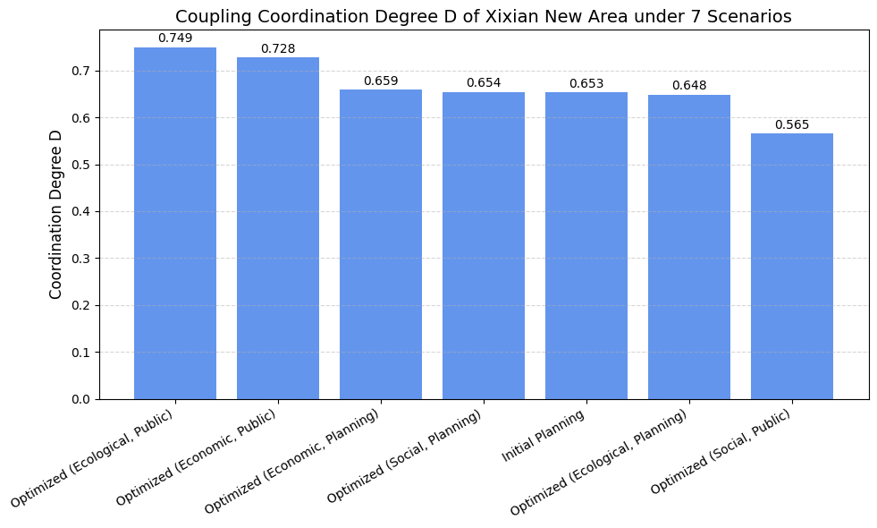

Figure 7 — Coupling Coordination Degree D of Xixian New Area under 7 Scenarios

**6.3 Trend Analysis and Comparison of Perspectives**

Through the D-value results, the following characteristics can be found:

The eco-optimisation model from the public perspective (D = 0.749) performs optimally, indicating that the optimisation of the eco-land structure not only achieves the improvement of the coordination of the three pillars, but also receives a high degree of recognition from the public;

D = 0.749 is from the Coupled Coordination Degree Model (CCDM). The D value of 0.749 from the public eco-optimisation model suggests that this optimised land use scenario not only ensures ecological integrity, but also achieves a high level of system coordination with a moderate balance of economic and social objectives. For the government or planners, this means prioritising green infrastructure investments; for the community, it means greater ecological benefits and livability.

The economic optimisation model under the public perspective (D = 0.728) also shows a high level of coordination, which can be seen as a reflection of the public's preference for a balance between development and the environment;

The economic optimisation model under the planning perspective (D=0.659) is better than the ecological optimisation model (0.648) and the social optimisation model (0.654), reflecting the more synergistic nature of the economically oriented land use structure in the government's orientation in the current conditions;

The initial planning scenario model (D=0.653) is located at a medium level, indicating that the original structure of Xixian New Area still has a certain degree of reasonableness without optimising and adjusting the land use ratio;

The social optimisation model from the public perspective (D=0.565) is at the lowest level of synergy, indicating that the ‘single intensive social land use’ lacks ecological and economic support in the existing structure, which is not conducive to the coordination of the overall system.

**6.4 Identification of optimal scenarios and analysis of specific results**

① Comparison of optimisation ranking under different perspectives

(1) Optimisation ranking of scenarios under the public perspective

According to the simulation results, the D values of the three scenarios under the public perspective are ranked as follows:

Ecological scenario optimisation scheme D = 0.749

Economic scenario optimisation scheme D = 0.728

Social scenario optimisation scheme D = 0.565

This ranking shows that the public is more concerned with the protection of the ecological environment, followed by the enhancement of economic vitality, while the centralised development of social infrastructure instead lacks ecological and economic support in the current structure, resulting in the weakest coordination. The ecologically optimal structure under the public perspective not only preserves the green infrastructure to the maximum extent, but also maintains the integrity of the basic functions in the economic and social dimensions.

(2) Scenario sequencing under the government planning perspective

The D-value ranking of the three scenario optimisation options under the government planning perspective is as follows:

Economic scenario optimisation scheme D = 0.659

Social optimisation scheme D = 0.654

Ecological scenario optimisation scheme D = 0.648

This result reflects that the government is more inclined to pursue the balance between economic benefits and livelihood protection in urban development, and gives more importance to productive and service land in planning. The ecological optimisation scenario, on the other hand, performs relatively weakly under the planning weights, showing that the government's reconstruction of ecological functions in spatial allocation has not yet become a priority.

② Analysis of average coordination degree and identification of optimal scenarios

In order to identify the optimal scenarios, this study averages the D values of the three types of scenarios for the two perspectives, and the results are as follows:

Ecological scenario optimisation scheme average D = (0.749 + 0.648) / 2 = 0.698

Economic scenario optimisation scheme average D = (0.728 + 0.659) / 2 = 0.693

Social scenari optimisation scheme average D = (0.654 + 0.565) / 2 = 0.610

Numerically, the ecological scenario has the highest average degree of coordination and can be identified as the optimal scenario optimisation in the framework of this study, while the ecological scenario is also the best scenario among the three objective scenarios. This suggests that under the current land use structure and three-dimensional objective weighting system, the ecological scenario optimisation is most likely to achieve the greatest degree of coordination of the ternary system (ecology-society-economy) and has the strongest potential for sustainable development.

It is also worth noting that the average degree of coordination of the three scenarios under the public perspective is:

Public perspective average D = (0.749 + 0.728 + 0.565) / 3 ≈ 0.681

And the average degree of coordination of the three scenarios under the government planning perspective is:

Government perspective average D = (0.648 + 0.654 + 0.659) / 3 ≈ 0.654

D for the initial planning scenario = 0.653

This indicates that the optimisation results under the public perspective have higher system coordination, and the optimisation solutions generated by the current optimisation algorithm are closer to the public's sustainable preferences and demands. Although the optimisation from the government's perspective is slightly lower, its coordination is still higher than that of the initial planning scheme, indicating that the optimisation scheme is still effective from the government's perspective. The government's original proposal has a certain foundation in terms of system rationality.

③Comparative Interpretation of the Initial Planning Scenarios

Among the seven models, the D-value of the initial planning scheme is 0.653, which is higher than the public perspective social optimisation model (0.565) and the government perspective ecological optimisation model (0.648). This result shows that the initial planning scenario proposed by Xixian New Area has achieved multi-objective balance to a certain extent without optimisation, and has high feasibility and scientificity. However, at the same time, the system coordination can still be further improved through algorithmic optimisation (e.g., ecological scenario D = 0.749), which provides a quantitative basis and directional guidance for future planning updates.

**7 Optimal scenario analysis and its policy recommendations**

Guided by the three pillars of ecological, economic and social sustainability, this chapter evaluates seven land-use allocation scenarios optimally generated through genetic algorithms. The aim is to determine which scenario best reconciles the sustainability objectives. This was done by simulating land use reallocations under realistic constrained conditions and quantified through metrics-based scoring and CCDM analysis.

**7.1 Optimal Scenario Identification and Result Analysis**

Based on the analysis of the results of the coupled coordination model in Chapter 6, among the seven simulation scenarios with different weighting perspectives and goal orientations, the ‘ecological optimisation - public perspective’ scenario has the highest coordination score (D = 0.749). Meanwhile, the average score of the two perspectives of the eco-optimisation scenario was significantly better than that of the original planning scenario and the other two optimisation scenarios. The Eco-Optimisation scenario was identified as the optimal scenario because it showed the strongest system coordination.

In the optimisation scenario under the ecological scenario, under the public perspective, the ecological objective layer scores 55.09, the economic objective layer scores 20.74, and the social objective layer scores 2.94. Although the distribution of the three is quite different, from the T and D values of the coordination model, the enhancement of the ecological orientation significantly promotes the synergy effectiveness of the overall system, showing that the ecology-centered development path has a high degree of feasibility and public opinion under the weight of the public.

The value 55.09 refers to the average ecological objective score across the five clusters (Jinghe, Airport, Qinhan, Fengxi, and Fengdong) under the optimal ecological scenario. This average is not directly shown in the figure8, which presents individual cluster scores. The average is used in the Coupled Coordination Degree Model (CCDM) to represent the overall ecological performance of the entire New Area system.

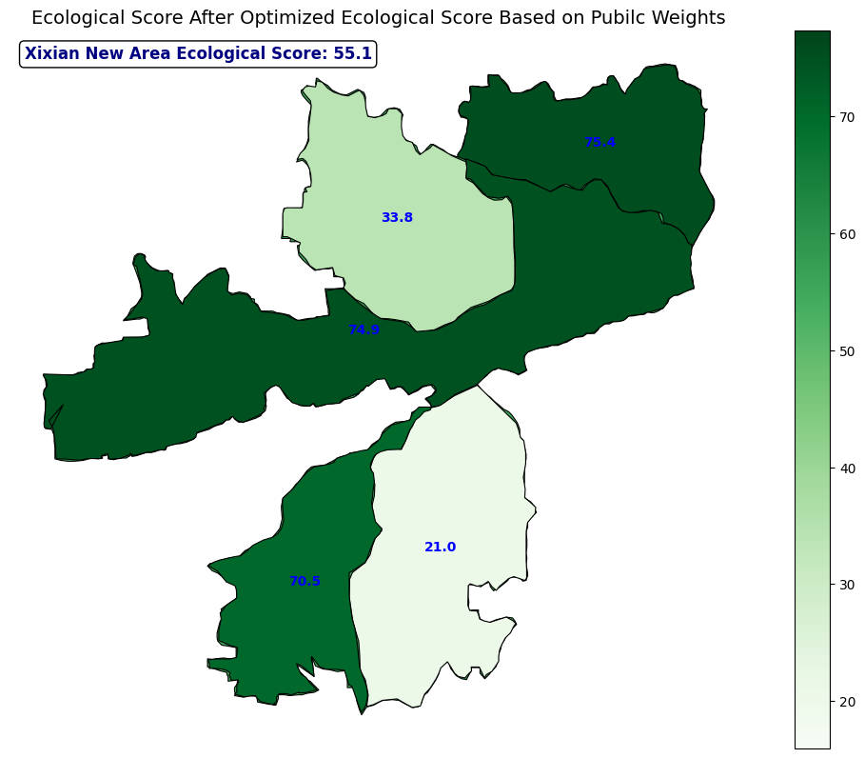

Figure 8 — Ecological Score After Optimized Ecological Score Based on Pubilc Weights

The above figure shows the spatial distribution of the ecological scores of the five functional clusters of Xixian New Area under the optimal scenario: Jinghe New City (75.4) and Qinhan New City (74.9) have the best ecological performance, followed by Fenghai New City (70.5); the ecological performances of Airport New City (33.8) and Fenghuang New City (21.0) are weak, which reflects the ecological variability of the different areas due to the functional structure and land use planning.

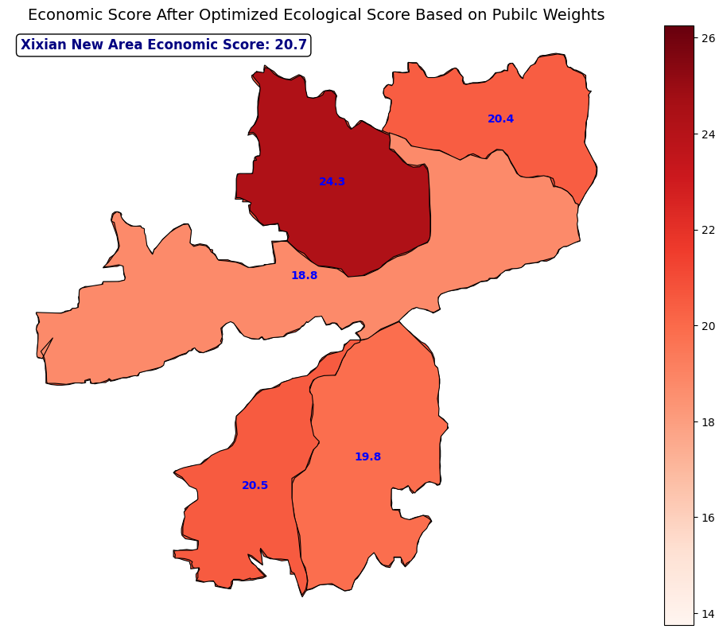

Figure 9 — Economic Score After Optimized Ecological Score Based on Pubilc Weights

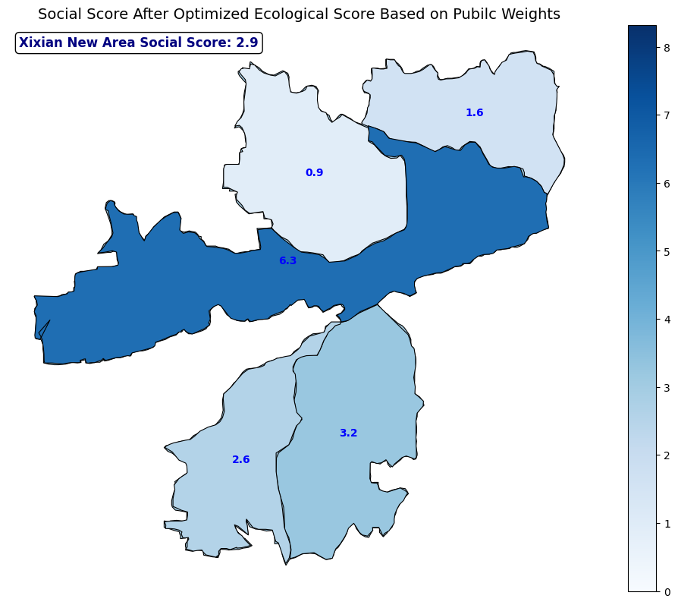

Figure 10 — Social Score After Optimized Ecological Score Based on Pubilc Weights

Figures 8 and 9 show the economic and social scores under this scenario, respectively, indicating that the eco-prioritized development path sacrifices some social equity and economic benefits while still maintaining a high economic score (20.7 for the whole region) and a high basic social service score (2.9 for the whole region), which reflects the compatibility of the ecological transition.

Explanation:

The economic scores of the clusters reflect the situation of the land use types under the economic target layer such as industrial and commercial land use. For example, Fengdong New Town's score of 24.3 under the eco-optimisation scenario indicates that the region retains a significant proportion of economic land types, particularly logistics and bonded zones that support the Airport Economic Belt [15]. These zones contribute to regional GDP and employment and are therefore economically vital even in an eco-prioritised strategy.

The social score measures the adequacy and spatial distribution of land categories that support public services and community well-being, such as housing, education, healthcare, and culture. Among the ecological scenarios, Qinhan New Town scores higher due to its preservation of the layout of schools, parks and cultural institutions. On the contrary, Airport New Town scores lower because industrial dominance reduces the proportion of socially supportive land. These scores indicate the ability of the clusters to maintain an inclusive, liveable and socially resilient environment [16].

**7.2 Recommendations for regional development under the optimal scenario**

As shown in Figure 1, the following cluster optimisation recommendations are made in conjunction with the spatial distribution of scores and regional functional positioning:

(1)The lowest ecological score of 33.8 for Airport New City reflects that its land structure is over-represented in aviation logistics and industrial land, with insufficient ecological green space coverage and serious fragmentation of the water system. It is recommended to strengthen the ecological infrastructure configuration, expand the green space and water space, and guide the development of low-carbon logistics and green airside economy, so as to improve the regional ecological adaptability and industrial synergy effect [16] [17].

(2)Fengdong New City has a weak ecological performance, and its low ecological score is mainly due to the centralised layout of industries and uneven distribution of public service facilities. It is recommended to accelerate the construction of green infrastructure, adjust the structure of industry and service facilities, and improve the regional ecological carrying capacity and quality of human environment.

(3)Qinhan New City, with a high score of 74.9, demonstrates a good ecological-cultural spatial synergy mechanism. Historical and cultural heritage protection zones and ecological corridors in the region are laid out in synergy, and the integration of ecological and cultural functions is remarkable. It is recommended to continue to strictly abide by the ecological red line, promote the construction of low-carbon cultural tourism, and create a core area integrating ecological, cultural and tourism functions [15].

(4)Fengxi New City shows significant ecological advantages, with sufficient green space resources and a relatively balanced layout, and has formed some ecological R&D and green residential areas. It is recommended to further strengthen the green space network, promote the construction of the demonstration area of ‘scientific research + ecological residence’, and enhance the integration of ecological residence.

(5)Jinghe New City, with the highest ecological score of 75.4, has established its status as a model green new city. The area has contiguous ecological land and complete agricultural space, with strong ecological connectivity and system integrity. It is recommended to use it as a template for the development of green new areas, strengthen the linkage with neighbouring agro-ecosystems, and improve the overall ecological network function and system carrying capacity [15].

**7.3 Policy Recommendations under Ecological Orientation**

(1) Strengthen ecological spatial zoning management: establish a hierarchical ecological spatial control system, clarify the “ecological red line” and “development boundary”, and strengthen the ecological constraint mechanism of land use.

(2) Promote the construction of green infrastructure: Prioritize the development of green transportation systems, rain gardens, urban forests, etc., to enhance the ecological resilience and regulatory function of the land use system.

(3) Improve the green incentive mechanism: through green credit, ecological compensation, land use volume incentives and other means, guide the main body of development to the ecological priority mode, and stimulate the market ecological protection endogenous motivation.

(4) Enhance public participation and transparency: Improve the public participation planning mechanism, establish a multi-body consultation mechanism in land use adjustment and project review, and enhance public recognition and scenario adaptation.

(5) Construct a scenario-based assessment system: establish a dynamic feedback system based on the coupling coordination degree, incorporate the results of scenario simulation into the planning implementation assessment cycle, and form a “simulation-implementation-feedback-optimization” circular mechanism.

**7.4 Summary**

Based on the optimization simulation and coordination results, this chapter clarifies that the ecological orientation and public perspective scenario is the most coordinated development path at present, and proposes regional differentiated development countermeasures in combination with the spatial performance of the five functional clusters in Xixian New Area. Meanwhile, five systematic policy recommendations are proposed for the implementation needs under the ecological orientation, which provide theoretical and practical support for the implementation of green development strategies in the future.

**8 Construction of Green Development Supervision System**

**8.1 Background and Research Logic**

As a state-level new area, the greenness and sustainability of the development model of Xixian New Area is not only related to the overall situation of the high-quality development of Guanzhong Urban Agglomeration, but also an important practice position for the implementation of the national ecological civilization construction strategy. Although the optimal land use scenarios have been constructed through the coupled coordination model and multi-scenario simulation method, there is still a lack of a standardized and operable system to monitor and dynamically evaluate the development path after the implementation of these scenarios.

Therefore, this chapter proposes to construct the “Green Development Evaluation System of Xixian New Area”, in order to achieve regular quantitative assessment of the sustainable development status of the five functional clusters of Xixian New Area in the three major dimensions of ecology, society and economy, and to promote the continuous optimization of the land use pattern and modernization of the governance capacity.

**8.2 Indicator System Construction and Reference**

Through the study of the national indicator system, the element layer and indicator layer of the urban green development indicator system are sorted out. Combined with the local situation of Xixian New Area, establish the indicator system of green development construction in Xixian New Area, and determine the corresponding weights and evaluation methods, so as to provide a guarantee for accurately analyzing the level of green development construction in Xixian New Area in the future.

Table 8 — China's National Green Development Indicator System: Example of one type of indicator Resource Use

|  |  |  |  |  |
| --- | --- | --- | --- | --- |
| Secondary Indicator | Unit | Indicator Type | Weight (%) | Data Source |
| Total energy consumption | 10,000 tons of standard coal | Key Monitoring Indicator (1.83%) | 1.83 | National Bureau of Statistics, National Development and Reform Commission |
| Energy consumption per unit of GDP decreased | % | Mandatory Constraint Indicator (2.75%) | 2.75 | National Bureau of Statistics, National Development and Reform Commission |
| CO2 emissions per unit of GDP decreased | % | Mandatory Constraint Indicator (2.75%) | 2.75 | National Development and Reform Commission, National Bureau of Statistics |
| Proportion of non-fossil energy in primary energy consumption | % | Mandatory Constraint Indicator (2.75%) | 2.75 | National Bureau of Statistics, National Energy Administration |
| Total water consumption | 100 million cubic meters | Key Monitoring Indicator (1.83%) | 1.83 | Ministry of Water Resources |
| Water consumption per 10,000 yuan of GDP decreased | % | Mandatory Constraint Indicator (2.75%) | 2.75 | Ministry of Water Resources, National Bureau of Statistics |

Continuation table 8

|  |  |  |  |  |
| --- | --- | --- | --- | --- |
| Water consumption per unit of industrial added value decreased rate | % | Key Monitoring Indicator (1.83%) | 1.83 | Ministry of Water Resources, National Bureau of Statistics |
| Effective utilization coefficient of farmland irrigation water | — | Key Monitoring Indicator (1.83%) | 1.83 | Ministry of Water Resources |
| Amount of cultivated land | 100 million mu | Mandatory Constraint Indicator (2.75%) | 2.75 | Ministry of Land and Resources |
| Scale of newly added construction land | 10,000 mu | Mandatory Constraint Indicator (2.75%) | 2.75 | Ministry of Land and Resources |
| Per unit of GDP Reduction rate of construction land area | % | Key Monitoring Indicator (1.83%) | 1.83 | Ministry of Land and Resources, National Bureau of Statistics |
| Resource output rate | 10,000 yuan/ton | Key Monitoring Indicator (1.83%) | 1.83 | National Bureau of Statistics, National Development and Reform Commission |
| Comprehensive utilization rate of general industrial solid waste | % | Important Green Indicator (0.92%) | 0.92 | Ministry of Environmental Protection, Ministry of Industry and Information Technology |
| Comprehensive utilization rate of crop straw | % | Important Green Indicator (0.92%) | 0.92 | Ministry of Agriculture |

There are seven primary indicators and 56 secondary indicators in the national system.

Among the first-level indicators:

1. Resource Use (Weight = 29.3%)

2. Environmental Management (Weight = 16.5%)

3. Environmental Quality (Weight = 19.3%)

4. Ecological Protection (Weight = 16.5%)

5. Quality of Growth (Weight = 9.2%)

6. Green Lifestyle (Weight = 9.2%)

7. Public Satisfaction (Not Weighted)

Secondary indicators:

1 Total energy consumption

2 Energy consumption per unit of GDP decreased

3 CO2 emissions per unit of GDP decreased

4 Proportion of non-fossil energy in primary energy consumption

5 Total water consumption

6 Water consumption per 10,000 yuan of GDP decreased

7 Water consumption per unit of industrial added value decreased rate

8 Effective utilization coefficient of farmland irrigation water

9 Amount of cultivated land

10 Scale of newly added construction land

11 Per unit of GDP Reduction rate of construction land area

12 Resource output rate

13 Comprehensive utilization rate of general industrial solid waste

14 Comprehensive utilization rate of crop straw

15 Reduction in total chemical oxygen demand emissions

16 Reduction in total ammonia nitrogen emissions

17 Reduction in total sulfur dioxide emissions

18 Reduction in total nitrogen oxide emissions

19 Hazardous waste disposal utilization rate

20 Harmless treatment rate of domestic waste

21 Centralized sewage treatment rate

22 Proportion of investment in environmental pollution control in GDP

23 Ratio of days with good air quality

24 Decrease in concentration of cities that do not meet PM2.5 standards

25 Proportion of surface water reaching or better than Class III water bodies

26 Proportion of surface water inferior to Class V water bodies

27 Ratio of compliance with standards for water function areas of important rivers, lakes and reservoirs

28 Ratio of compliance with standards for centralized drinking water sources

29 Proportion of good water quality in coastal waters

30 Safe utilization rate of polluted cultivated land

31 Fertilizer use per unit of cultivated land

32 Pesticide use per unit of cultivated land

33 Forest Coverage rate

34 Forest stock

35 Comprehensive vegetation coverage of grassland

36 Natural coastline retention rate

37 Wetland protection rate

38 Area of ​​nature reserves (land)

39 Area of ​​nature reserves (marine)

40 Additional water and soil erosion control area

41 Controllable desertification land control rate

42 Additional mine restoration and control area

43 GDP growth rate per capita

44 Per capita disposable income of residents

45 Proportion of tertiary industry in GDP

46 Proportion of added value of strategic emerging industries in GDP

47 Proportion of R&D expenditure in GDP

48 Per capita energy consumption reduction rate of public institutions

49 Market share of green products

50 Growth rate of new energy vehicle ownership

51 Green travel (public transportation passenger volume per 10,000 people)

52 Proportion of green buildings in towns and cities in newly built buildings

53 Green space rate of urban built-up areas

54 Rural tap water penetration rate

55 Rural sanitary toilet penetration rate

56 Public satisfaction with the ecological environment.

Some of the indicators in the National Green Development Indicator System that are not suitable for Xixian New Area are removed for the following reasons:

Table 9 — Reasons for the deletion of indicators

|  |  |  |
| --- | --- | --- |
| Original National Indicator No. | Indicator Name (Original) | Reason for Removal |
| 29 | Proportion of good water quality in coastal waters | Xixian New Area is inland; marine-related indicators are not applicable. |
| 38 | Area of marine nature reserves | Same as above; no marine protection zones in Xixian. |
| 36 | Natural coastline retention rate | Designed for coastal provinces; Xixian has no coastline. |
| 39 | Area of marine protected areas | Also a marine indicator; lacks geographic relevance. |
| 30 | Safe utilization rate of polluted arable land | Data unavailable; low proportion of agricultural land in the region. |
| 40 | Additional water and soil erosion control area | Data updated irregularly; difficult to quantify consistently. |

Continuation table 9

|  |  |  |
| --- | --- | --- |
| 42 | Additional mine restoration and control area | No significant historical mining legacy in Xixian. |
| 48 | Reduction rate of per capita energy consumption in public institutions | Scattered data sources; hard to form unified monitoring system. |
| 49 | Market share of green products | Market-based indicator with high volatility; weak correlation with land planning. |
| 51 | Public transport passengers per 10,000 people | Already replaced by “share of public transport travel” in evaluation. |
| 54 | Rural tap water penetration rate | Xixian is a new urban area; municipal coverage better reflects water access. |
| 55 | Rural sanitary toilet penetration rate | Urban context unsuitable for evaluating rural sanitation indicators. |
| 31 | Fertilizer use per unit of cultivated land | Agricultural land proportion is extremely small; lacks comparability. |
| 32 | Pesticide use per unit of cultivated land | Difficult to track accurately; affected by many external factors. |

After the deletion, their weights were divided equally among the secondary indicators of the same broad category. The Xixian New Area index system has a total of 42 second-class indicators

**8.3 Calculation and working principle of green development indicator system**

The Green Development Index (GDI) is calculated by weighting the average of the individual indices of 42 indicators, except for “Public Satisfaction”.

The formula is:

  (17)

Z is the green development index,

 is the individual index of the indicator, and

N is the number of indicators.

 is the weight of indicator Yi.

Green development indicators are divided into positive and negative indicators according to their evaluation role, and into absolute and relative indicators according to the nature of their data, which need to be dimensionless for each indicator. The specific processing method is to convert absolute indicators into relative indicators, reverse indicators into positive indicators, and aggregate control indicators into annual growth control indicators before calculating individual indices.

**8.4 Summary of this chapter**

This chapter focuses on the sustainable land use and green development needs of Xixian New Area, and constructs a set of targeted and well-structured green development supervision system. Based on the full reference to China's Green Development Indicator System, combined with the spatial characteristics and data availability of the Xixian New Area, it completes the deletion and optimization of the indicator system, and finally forms a comprehensive evaluation system.

**9 Conclusion and Outlook**

**9.1 Main Research Findings**

This study, centering on the Xixian New Area as a representative case of China's state-level new urban districts, constructed and tested a comprehensive framework for evaluating and optimizing sustainable land use through multi-scenario simulation. The main findings are as follows:

A multi-level evaluation system of sustainable land use was established, incorporating ecological, social, and economic dimensions, which was aligned with the UN Sustainable Development Goals (SDGs). The system reorganized 18 land use types into a structured evaluation matrix.

Using the entropy weight method, the official planning perspective was transformed into quantifiable weights, while public preferences were introduced through a structured questionnaire survey (N = 512), producing demand-side weights for three development scenarios.

A genetic algorithm was used to simulate optimal land allocations under three guiding scenarios (ecological, social, economic), subject to realistic spatial and land area constraints. Each scenario emphasized the maximization of a corresponding sustainability pillar.

A coupling coordination model quantitatively assessed the balance and synergy among the three sustainability goals under different scenarios. Among seven weighting combinations, the ecological optimization scenario based on public perspective achieved the highest coordination score (D = 0.749), thus being identified as the optimal land use scenario.

A set of spatial policy recommendations were proposed based on the differentiated performance of the five functional clusters (Airport, Fengdong, Qinhan, Fengxi, and Jinghe), including ecological reinforcement, public service enhancement, and strategic industrial zoning.

Finally, a green development supervision system was constructed, drawing on China’s national Green Development Indicator System while adapting to Xixian’s unique urban development stage. A revised indicator system with 42 indicators was developed, allowing annual monitoring of sustainability performance by region and theme.

**9.2 Contributions of the Study**

This research provides both theoretical innovation and practical application:

Theoretically, it integrates multiple modeling tools—entropy weight method, genetic algorithm, and coupling coordination model—into a coherent framework for scenario-based land use planning evaluation.

Practically, it bridges top-down planning perspectives with bottom-up public preferences, promoting participatory planning in emerging urban regions.

The development of a quantifiable, spatially sensitive green development supervision mechanism adds an operable layer to long-term planning enforcement, suitable for integration into regional digital governance platforms.

**9.3 Limitations and Future Research**

Although the research model has been rigorously constructed and verified with real data, the study has certain limitations:

The questionnaire survey was limited in geographic spread and demographic depth; future research can incorporate broader stakeholder groups including local government, business sectors, and marginalized populations.

Land use types were classified into 18 generalized categories for model efficiency; more granular land use data could further improve model resolution and policy targeting.

The model assumes a static regulatory and policy environment. However, future spatial developments are subject to evolving governance and market dynamics, which could be modeled using adaptive learning algorithms or agent-based simulations.

In future work, it is suggested to explore the integration of satellite-based remote sensing indicators, real-time urban sensing data (e.g., traffic, pollution), and machine learning prediction models to enhance the accuracy, adaptability, and policy responsiveness of land use sustainability planning in rapidly urbanizing regions.

The performed research and obtained results correspond to the direction of training 07.04.04 Urban Planning .

**Reference**

1. . United Nations. Transforming Our World: The 2030 Agenda for Sustainable Development [EB/OL]. (2015) [2025-01-13]. [https://sdgs.un.org/goals](https://sdgs.un.org/goals" \t "_new) [↑](#endnote-ref-0)
2. . The Central Committee of the Communist Party of China, The State Council. Opinions on Accelerating the Promotion of Ecological Civilization Construction [Z]. Beijing: National Development and Reform Commission, 2015. [↑](#endnote-ref-1)
3. . National Development and Reform Commission. Green Development Indicator System of China (Trial) [Z]. Beijing: National Development and Reform Commission, 2016. [↑](#endnote-ref-2)
4. . Shmelev, S. (2019). Sustainable Cities Reimagined: Multidimensional Assessment and Smart Solutions. Routledge. [↑](#endnote-ref-3)
5. . Shmelev, S. E., & Shmeleva, I. A. (2025). Smart and sustainable benchmarking of cities and regions in Europe: The application of multicriteria assessment. Cities, 156, 105533. [↑](#endnote-ref-4)
6. . Hair, J. F., Black, W. C., Babin, B. J., & Anderson, R. E. (2010). Multivariate Data Analysis. Pearson Education. [↑](#endnote-ref-5)
7. . Fang, C., Zhou, C., & Gu, C. (2017). Coupling coordinated development between urbanization and the eco-environment in China. Journal of Geographical Sciences, 27(7), 871–888. [↑](#endnote-ref-6)
8. 8. X. Li. Experience of Urban Functional Construction in Tokyo Metropolitan Area and Its Enlightenment to China [M]. Beijing: Urban Planning Press, 2019. [↑](#endnote-ref-7)
9. . Howard, E. (1902). Garden Cities of To-morrow. London: Swan Sonnenschein & Co. [↑](#endnote-ref-8)
10. . Meadows, D. H., Meadows, D. L., Randers, J., & Behrens III, W. W. (1972). The Limits to Growth. New York: Universe Books. [↑](#endnote-ref-9)
11. . Department of Trade and Industry (UK). Our Energy Future – Creating a Low Carbon Economy [Z]. London: HM Government, 2003. [↑](#endnote-ref-10)
12. . Tonks E., Shmelev S. E. (2019). Comparative analysis of indicator-based urban sustainability assessment frameworks. In: Shmelev (Ed.) Sustainable Cities Reimagined: Multidimensional Assessment and Smart Solutions. Routledge. [↑](#endnote-ref-11)
13. . Shmelev S. E., Agbleze L., Spangenberg J. H. (2023). Multidimensional Ecosystem Mapping: Towards a More Comprehensive Spatial Assessment of Nature’s Contributions to People in France. Sustainability, 15(9), 7557. [↑](#endnote-ref-12)
14. . Zhang B., Shmelev S. E. (2019). Multidimensional sustainability assessment for the cities of the Global South. In: Shmelev (Ed.) Sustainable Cities Reimagined: Multidimensional Assessment and Smart Solutions. Routledge. [↑](#endnote-ref-13)
15. . Shmelev, S. E., & Shmeleva, I. A. (2019). Global urban sustainability assessment: A multidimensional approach. Sustainable Development, 1–17. [↑](#endnote-ref-14)
16. . Xixian New Area Administrative Committee. Xixian New Area Territorial Spatial Planning (2021–2035) [Z]. Xi'an: Planning Bureau, 2021. [↑](#endnote-ref-15)
17. . Zhang, S., Guan, Z., Liu, Y., & Zheng, F. (2022). Land Use/Cover Change and Its Relationship with Regional Development in Xixian New Area, China. Sustainability, 14(11), 6889. https://doi.org/10.3390/su14116889 [↑](#endnote-ref-16)
18. . Wang Qikun. Spatial Planning Strategies of Xixian New Area Based on the Green Development Concept [M]. Master's thesis, Chang'an University, 2020. [↑](#endnote-ref-17)
19. . Ta Kung Pao. (2018, October 23). Collusion behind illegal villas in the Qinling Mountains: Rectification requires real action. [EB/OL]. Retrieved April 23, 2024, from [https://www.takungpao.com/news/232108/2018/1023/193619.html](https://www.takungpao.com/news/232108/2018/1023/193619.html" \t "_new) [↑](#endnote-ref-18)
20. . China Central Television. «Catching the Righteousness to the End». [R/OL].(2019–01–09)[2022–12–31].https://tv.cctv.com/2019/01/10/VIDAqDJVJOQcerEFq8wWDecc190110 .shtml. [↑](#endnote-ref-19)
21. . Xinhuanet. Xi'an: «Green Waters and Green Mountains» Build Power for High–Quality Development. [EB/OL].(2022–12–01)[2022–12–31].http://sn.news.cn/2022–12 /01/c\_1129175819.htm. [↑](#endnote-ref-20)
22. . Sanqin Metropolis Daily. The 2019 National Urban Water Conservation Publicity Week in Xi'an was launched. [EB/OL].(2019–05–10)[2022–12–31].https://www.sohu.com/a/ 313176117\_336604. [↑](#endnote-ref-21)
23. . Geng, Y., Zhou, W., Shi, F., et al. (2020). Risk Assessment of Groundwater Pollution in the Plain Areas of Xi’an City. Environmental Engineering, 38(12), 113–118. [↑](#endnote-ref-22)
24. . Xi'an Municipal Bureau of Ecology and Environment. «Three–Year Action Plan for the Protection and Management of Rivers and Lakes in Xi'an City with Global Water Control and Clean Water Prosperity» issued a blueprint for global water control to create a new pattern of water system governance. [EB/OL].(2019–12–31)[2022 –12–31].http://www.xa.gov.cn/gk/sthj/wrfz/5e605d73fd8508098dce7852.html. [↑](#endnote-ref-23)
25. . Sohu News. (2018, December 17). Chronology of Qinling illegal villa demolitions: Why did six central government orders fail to take effect immediately? [EB/OL]. Retrieved April 23, 2024, from [https://www.sohu.com/a/279315496\_100233340](https://www.sohu.com/a/279315496_100233340" \t "_new) [↑](#endnote-ref-24)
26. . Xi'an Municipal Government. Policy. [EB/OL].(2022)[2022–12–31].http://www.xa.gov.cn/. [↑](#endnote-ref-25)
27. . Xi'an Daily. Continuous improvement of Xi'an's ecological environment. [R/OL].(2022–10–12)[2022–12–31].http://stzg.china.com.cn/2022–10/12/content\_42135057. htm. [↑](#endnote-ref-26)
28. . Wenxiaobai. (n.d.). Qinling illegal villa case: Review of six rounds of central supervision. [EB/OL]. Retrieved April 23, 2024, from [https://www.wenxiaobai.com/api/expends/detail?article=655253b3-65e3-457d-bb7b-f917b54014fc](https://www.wenxiaobai.com/api/expends/detail?article=655253b3-65e3-457d-bb7b-f917b54014fc" \t "_new) [↑](#endnote-ref-27)
29. . People's Daily Online. Xi'an newly added urban green area of 9.05 million square meters. [EB/OL].(2021–04–23)[2022–12–31].http://sn.people.com.cn/n2/2021 /0423/c226647–34691806.html. [↑](#endnote-ref-28)
30. . Xi'an Municipal Bureau of Ecology and Environment. Announcement of information on the improvement of black and odorous water bodies in Xi’an City. [EB/OL]. (2020–09–09). http://www.xa.gov.cn/gk/sthj/wrfz/5fa368b4f8fd1c596642d09c.html. [↑](#endnote-ref-29)
31. . Xi'an Statistics Bureau. 2021 Xi'an Statistical Yearbook. [EB/OL]. (2021). http://tjj.xa.gov.cn/tjnj/2021/indexch.htm. [↑](#endnote-ref-30)
32. . The Ministry of Education of China. The Ministry of Education notified several recent issues concerning the development of local private compulsory education. [EB/OL].(2018–11–30)[2022–12–31].http://www.moe.gov.cn/ jyb\_xwfb/gzdt\_gzdt/s5987/201811/t20181130\_361997.html. [↑](#endnote-ref-31)
33. . Xi'an Daily. Green travel, low-carbon environmental protection: Shared bikes reduce carbon emissions by 13,000 tons. [EB/OL]. (2022–11–15) [2022–12–31].[http://www.xa.gov.cn/gk/sthj/lsdtfz/6372f27cf8fd1c4c21292bdd.html](http://www.xa.gov.cn/gk/sthj/lsdtfz/6372f27cf8fd1c4c21292bdd.html" \t "_new) [↑](#endnote-ref-32)
34. . Shaanxi press conference. Xi’an has a clear goal for the next five years. [EB/OL]. (2022–06–21). https://shaanxi.china.com/xian/20000906/20220621/25635023.html. [↑](#endnote-ref-33)
35. . Xi'an Urban Planning and Design Research Institute. 2021 Annual Report on Urban Transport Development in Xi’an. [EB/OL]. (2022–07–15) [2022–12–31].  
    https://aimg8.dlssyht.cn/u/2107993/ueditor/file/1054/2107993/1657588850986407.pdf [↑](#endnote-ref-34)
36. . Spangenberg, J. H. (2002). Institutional sustainability indicators: an analysis of the institutions in Agenda 21 and a draft set of indicators for assessing institutional sustainability. Sustainable Development, 10(2), 103–115. [↑](#endnote-ref-35)
37. . Zhu, Y., Tian, D., & Yan, F. (2020). The Effectiveness of the Entropy Weight Method in Multi-Criteria Decision-Making. Mathematical Problems in Engineering, 2020, 1–10. [https://doi.org/10.1155/2020/3564835](https://doi.org/10.1155/2020/3564835" \t "_new) [↑](#endnote-ref-36)
38. . Wang, J., & Xu, M. (2005). Coupling Degree Model and Its Application in Urban Spatial Coordination. Journal of Urban Planning and Development, 131(3), 120–126. [↑](#endnote-ref-37)
39. [↑](#endnote-ref-38)